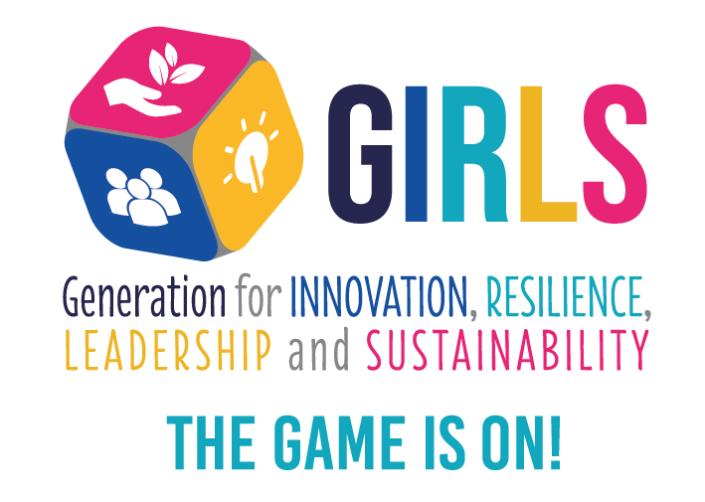
Dissemination Report
Date: <Date>
Doc. Version: v0.0

Document Control Information

Settings | Value
Document Title: | Dissemination Report
Project Title: | GIRLS “Generation for Innovation, Resilience, Leadership and Sustainability. The game is on!”
Document Author: | ISEC
Project Owner: | Project partnership
Project Manager: | USAL
Doc. Version: | v0.0
Sensitivity: | Public
Date: | 01/05/2023

Document Approver(s) and Reviewer(s):
NOTE: All Approvers are required. Records of each approver must be maintained. All Reviewers in the list are considered required unless explicitly listed as Optional.
Name | Role | Action | Date
All partners | Coordinators | Approve | 04/05/2023

Document history:
The Document Author is authorized to make the following types of changes to the document without requiring that the document be re-approved:
- Editorial, formatting, and spelling
- Clarification

To request a change to this document, contact the Document Author.
Changes to this document are summarized in the following table in reverse chronological order (latest version first).
Revision | Date | Created by | Short Description of Changes
 | 01/07/2023 | ISEC | Adaptation to the project templates

Configuration Management: Document Location
The latest version of this controlled document is stored in https://girsproject.eu/quality.

 | This project has been funded with support from the European Commission. This document reflects the views only of the authors, and the Commission cannot be held responsible for any use which may be made of the information contained therein.

TABLE OF CONTENTS
1. About the Dissemination Report 4
2. Dissemination Activities 5
2.1. Project Meetings 5
2.2. Contributions to workshops, conferences and journals 5
2.3. Project presentations and other events 5
2.4. Contributions to social networks 5
2.5. Newspapers and other contributions 5
2.6. Other dissemination activities 5
3. Dissemination Materials 5
4. Some dissemination Results 5
Appendix 1: 5

About the Dissemination Report
One of GIRLS Project goal is to disseminate the model to European higher education institutions (HEIs) through the partner networks and promote the dissemination all over Europe. For doing this, all partners collaborate in the dissemination of the project results.
The stakeholders of the project are teachers and students of higher education. The GIRLS Project is planned as an instrument to include innovation and digital tools in the European Higher Education Area and support European strategic cooperation in the field of education and training. Thus, in addition to students and professors from the partner universities, it will also be disseminated among the rest of the universities through congresses, conferences and workshops on educational innovation, new methodologies, transnational education, etc.
In addition to higher education, it will also reach participants in secondary and high school education, through partners and the European networks and platforms that facilitate communication between these institutions.
The NGO will give another approach to the project and an approach to society, which will make it easier for the project to also reach other social and solidarity organizations.
The project partners that participate in the project dissemination are the following:
- Universidad de Salamanca – USAL (Spain)
- Polytechnic Institute of Coimbra/Coimbra Engineering Institute – IPC/ISEC (Portugal)
- Spanish National Research Council - CSIC (Spain)
- University Francisco de Vitoria – UFV (Spain)
- Technical University of Civil Engineering Bucharest – UTCB (Romania)
- Agrupación Española de entidades de Lucha Contra la Leucemia y Enfermedades de la Sangre – AELCLÉS (Spain)
- Maristas Champagnat College (Spain)
- University Vasco de Quiroga A.C – UVAQ (Mexico)

Dissemination Activities

Project Meetings

Contributions to workshops, conferences and journals

Project presentations and other events

Contributions to social networks

Newspapers and other contributions

Other dissemination activities

Dissemination Materials

Some dissemination Results

Appendix 1:
<Use this section to reference (or append if needed in a separate annex) any relevant or additional information. Specify each reference or related document by title, version (if applicable), date, and source (e.g. the location of the document or the publishing organisation).>
ID | Reference or Related Document | Source or Link/Location
1 | <Example of a related document>  <03.Project_Charter.XYZ.11-11-2017.V.1.0.docx> | <Example of a location>  < U:\METHODS\ProjectX\Documents\>
2 | Project folder | <Insert project folder location.>
3

